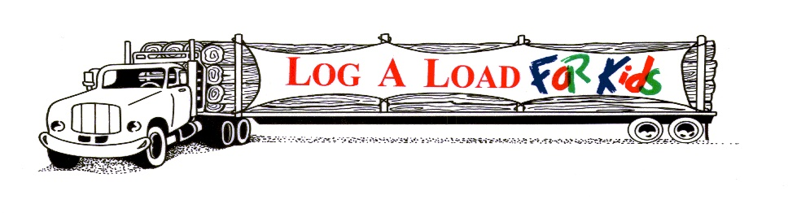

2025 LOG A LOAD FOR KIDS FOUNDATION
VOLUNTEER CHAMPION AWARD
NOMINATION FORM – DUE BY August 15, 2025

NOMINEE: Name:
Company:
Address:

Phone:
Email:
SPONSORED BY:
Name:
Company:
Address:

Phone:
Email:
Signature: ________________________________________________
Date: ________________________________________________

Mail Nominations to: Log A Load For Kids Foundation, Inc.
Attention: Sherri Hansen – Director
P.O. Box 168
Chewelah, WA. 99109
E-mail Nominations to: sherrihansen181@gmail.com & nationallogaloadforkids@gmail.com

NARRATIVE:
Please described the efforts, projects, or activities undertaken by the nominee that have demonstrated exemplary leadership in raising funds and/or advancing the Log A Load For Kids program. Please include pictures if you have them. You can choose to give examples of accomplishments or describe the impacts of the nominees work on the community, CMN hospitals, the forest products industry, and/or Log A Load For Kids.

