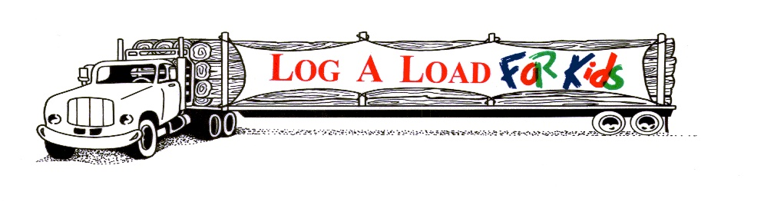

2024 LOG A LOAD FOR KIDS FOUNDATION
VOLUNTEER CHAMPION AWARD
NOMINATION FORM – DUE BY August 15, 2024

NOMINEE: Name:
Company:
Address:

Phone:
Email:

SPONSORED BY:
Name:
Company:
Address:

Phone:
Email:
Signature: ________________________________________________
Date: ________________________________________________

Mail Nominations to: Log A Load For Kids Foundation, Inc.
Attention: Sherri Hansen – Director
P.O. Box 168
Chewelah, WA. 99109
E-mail Nominations to: sherrihansen181@gmail.com & info@logaloadforkids.org

NARRATIVE:
Please described the efforts, projects, or activities undertaken by the nominee that have demonstrated exemplary leadership in raising funds and/or advancing the Log A Load For Kids program. You can choose to give examples of accomplishments or describe the impacts of the nominees work on the community, CMN hospitals, the forest products industry, and/or Log A Load For Kids.

